DBMS LAB EXERCISE1

1. Create MY_EMPLOYEE table with the following structure

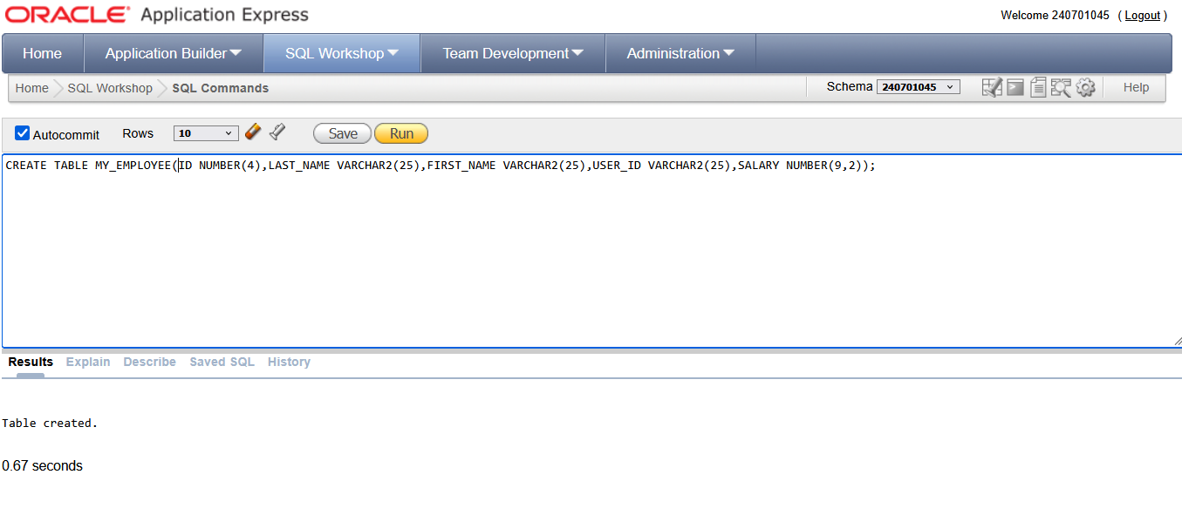

1. Add the first and second rows data to MY_EMPLOYEE table from the following sample

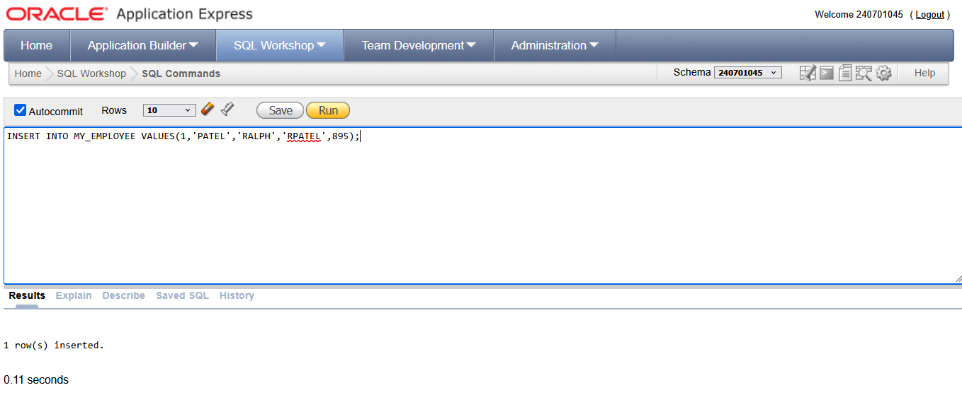

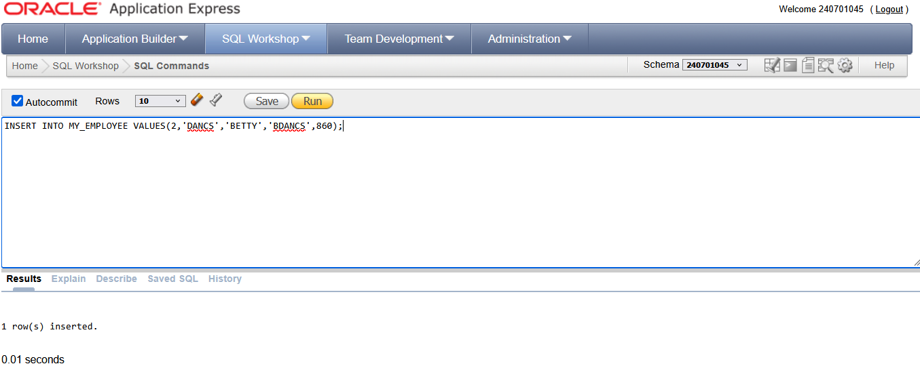

1. Display the table with values.

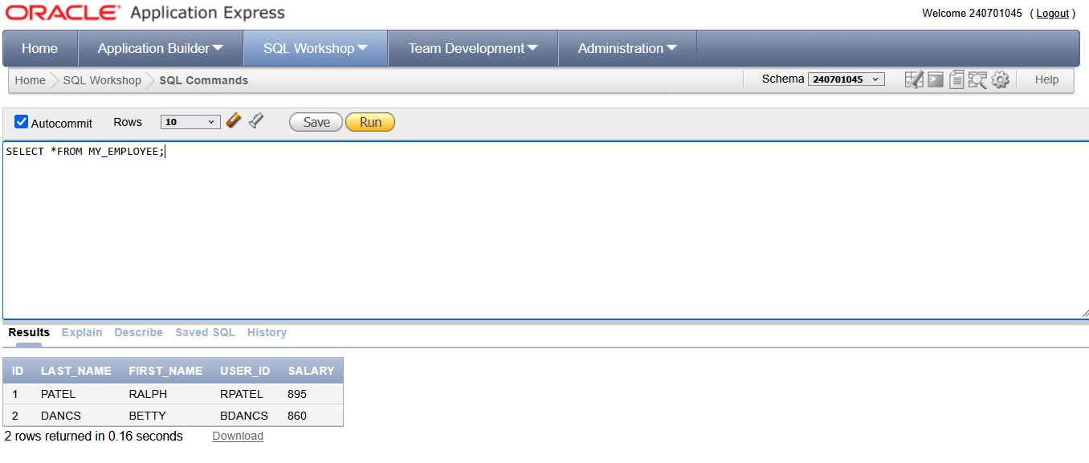

1. Populate the next two rows of data from the sample data. Concatenate the first letter ofthe first_name with the first seven characters of the last_name to produce Userid.

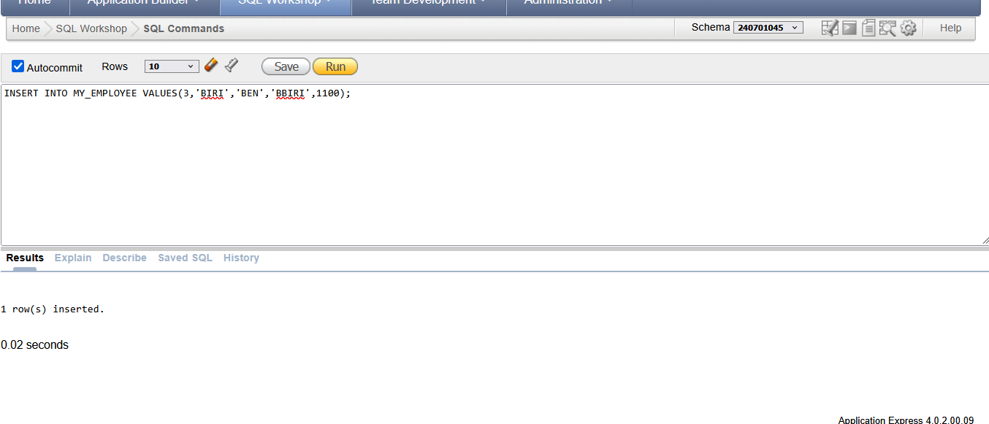

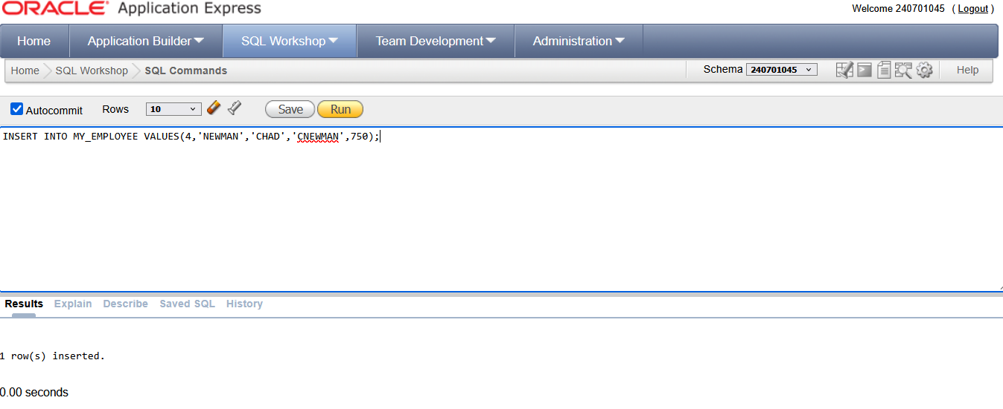

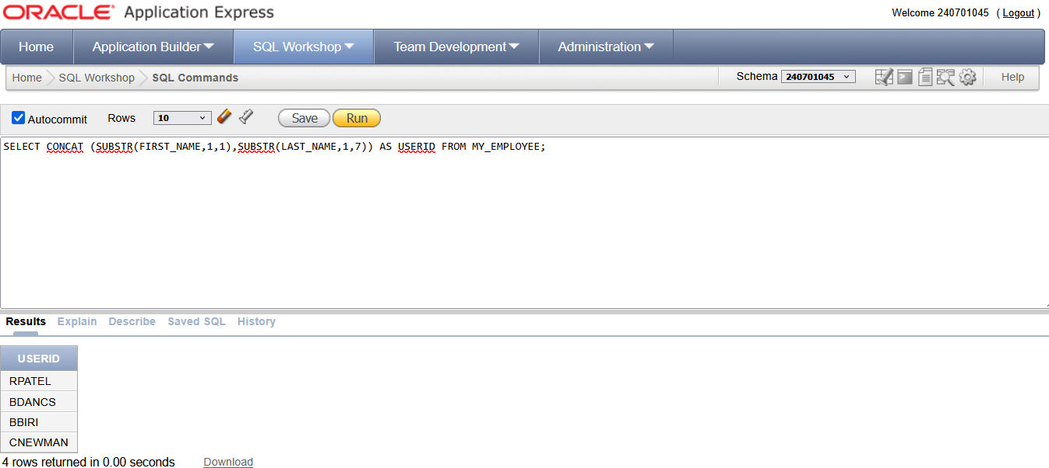

1. Delete Betty dancs from MY _EMPLOYEE table.

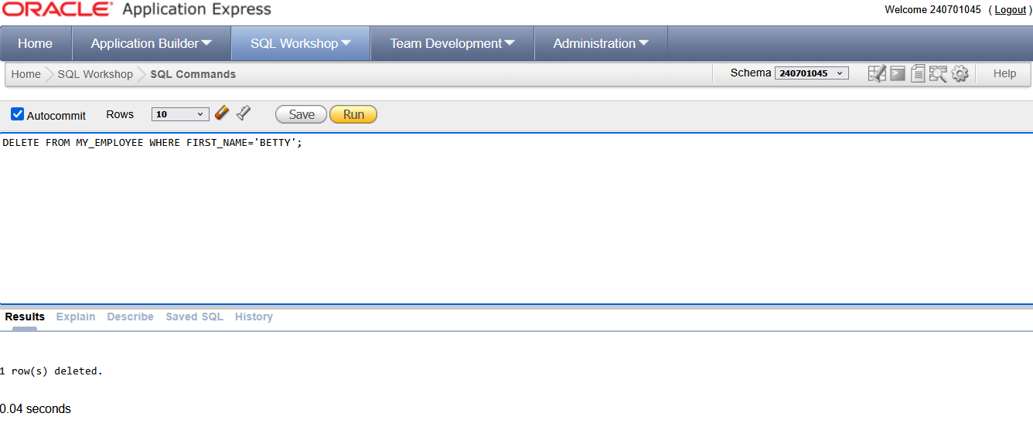

6.Empty the fourth row of the emp table.

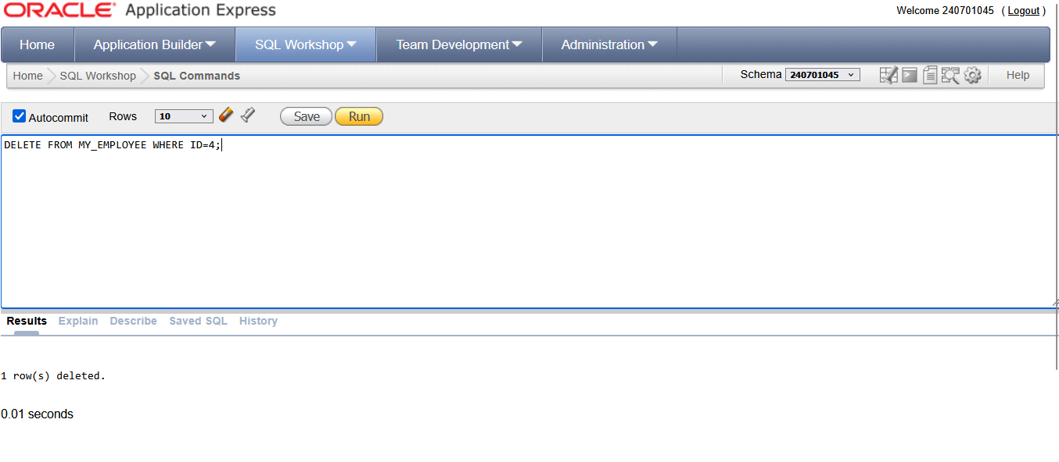

7.Make the data additions permanent

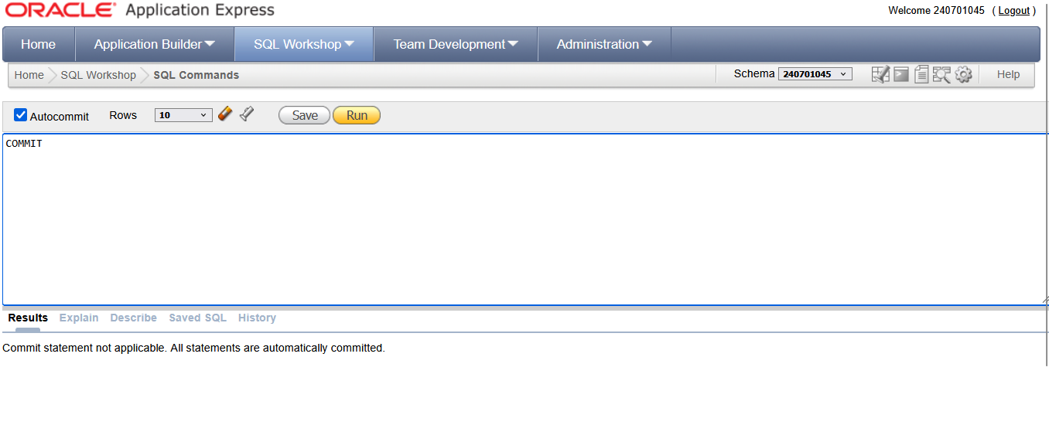

8.Change the last name of employee 3 to Drexler.

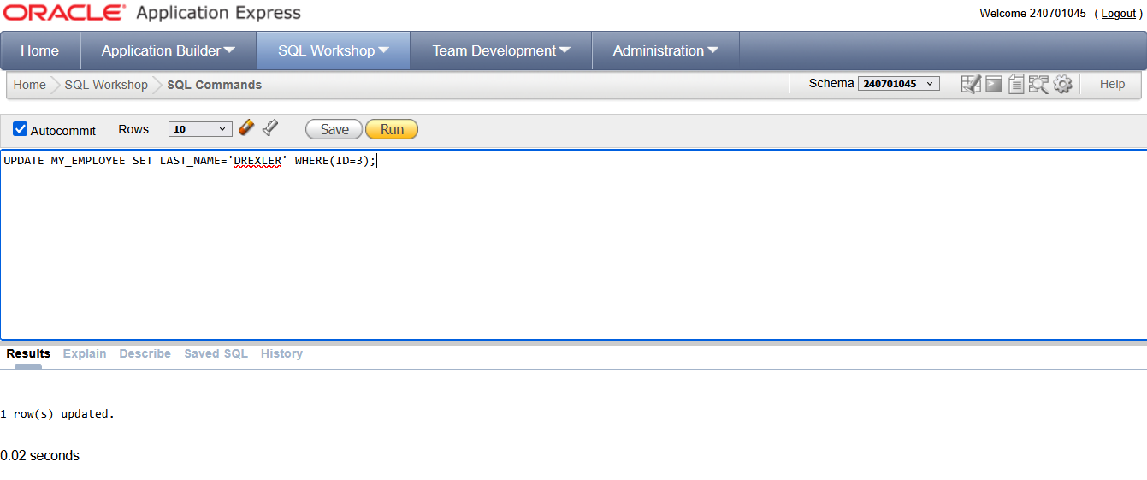

9.Change the salary to 1000 for all the employees with a salary less than 900. 